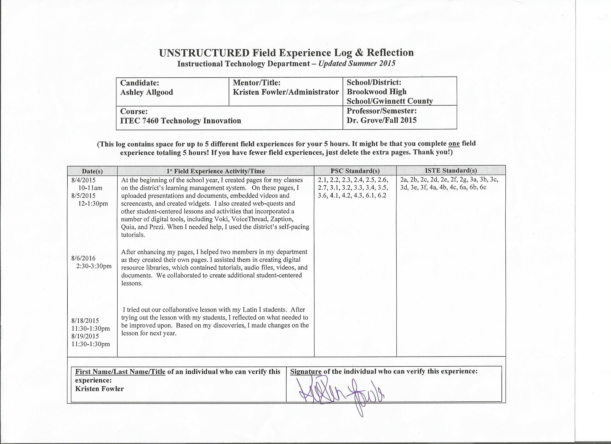
DIVERSITY
(Place an X in the box representing the race/ethnicity and subgroups involved in this field experience.)
Ethnicity | P-12 Faculty/Staff |  |  |  | P-12 Students
 | P-2 | 3-5 | 6-8 | 9-12 | P-2 | 3-5 | 6-8 | 9-12
Race/Ethnicity:
Asian |  |  |  | X |  |  |  | X
Black |  |  |  |  |  |  |  | X
Hispanic |  |  | X |  |  |  |  | X
Native American/Alaskan Native
White |  |  |  | X |  |  |  | X
Multiracial |  |  |  | X |  |  |  | X
Subgroups:
Students with Disabilities |  |  |  |  |  |  |  | X
Limited English Proficiency |  |  |  |  |  |  |  | X
Eligible for Free/Reduced Meals |  |  |  |  |  |  |  | X

Reflection
(Minimum of 3-4 sentences per question)
1. Briefly describe the field experience. What did you learn about technology coaching and technology leadership from completing this field experience?
While working on the district’s learning management system, I learned how to integrate various digital tools that I have learned in my technology classes. I used my knowledge of technology and LoTi levels to create engaging lessons for my students. I then shared my knowledge with my colleagues as I helped them enhance their own pages. I assisted them in troubleshooting as they experimented with various digital tools. Finally, we brainstormed how we could use these tools to make a web-quest on daily life culture in various countries.

2. How did this learning relate to the knowledge (what must you know), skills (what must you be able to do) and dispositions (attitudes, beliefs, enthusiasm) required of a technology facilitator or technology leader? (Refer to the standards you selected above. Use the language of the PSC standards in your answer and reflect on all 3—knowledge, skills, and dispositions.)
Knowledge - Through this experience, I was able to apply the knowledge I have gained on digital tools, LoTi levels, and coaching strategies. I was able to practice what I have been reading about. I used my knowledge to assess and apply new technologies. I deepened my knowledge through application in a real setting and learned troubleshooting techniques. Through reflection after the experience, I developed an understanding of the power of collaborative efforts.

Skills - This experience enabled me to apply my skills through application. I experimented with embedded various digital tools. Additionally, I was able to model for my colleagues methods of using these tools to create engaging lessons. During the collaboration with my colleagues, I was able to practice my active listening and partnership coaching skills.
Dispositions - An important part of this experience was the collaborative effort of creating the web-quest. It gave me that chance to listen to my colleagues’ ideas and learn from their experiences. As an instructional coach, active listening is an important part of my job. I am not there just to share my knowledge with others, but rather to learn from their experiences and find ways to combine their experiences with my training. This experience gave me an appreciation for what great things result from active listening and collaborations.
3. Describe how this field experience impacted school improvement, faculty development or student learning at your school. How can the impact be assessed?

Student learning has been improved by increasing the student engagement level of classroom lessons. By assisting my colleagues in utilizing the district’s learning management system and implementing digital tools in their lessons, the LoTi level of lessons has been increased. The changes will be seen in classroom assessments.

